Course Project Report on

“Online Banking”

Carried out By

**Batch No:01**

|  |  |
| --- | --- |
| Name of Students | USN |
| Rohan Kokatanur | 2GI18IS066 |
| Hemanth I T | 2GI18IS015 |
| Laxmi M N | 2GI18IS020 |
| Rachana Kampli | 2GI18IS032 |

Under the Guidance of

**Prof.Sudhindra B.Deshpande**

**KLS, GIT, Department of ISE, Belagavi**

**Course Name: Database Management System**

**Semester: IV**

**Course Code: 18IS43**

**DEPARTMENT of INFORMATION SCIENCE AND ENGINEERING**

**Academic Year 2019-20**

**Table of Contents**

1. INTRODUCTION 5

2. Literature Survey 6

3. Database Design 7

3.1 ER-Model 7

3.2 Relational Model 7

3.3 ER-Relational Mapping 7

4. Database Normalization 8

5. Table creations 12

6. Populating Tables 13

7. User Interface Designs 14

8. SQL Queries 14

9. Conclusions 15

10. References 16

**Course project report and ppt content**

1. Title

2. Problem statement for that the project

3. Need Analysis, Variables involved

4. Atleast two alternate solutions to solve the problem defined or meet the need analysis

5. Comparison between the solutions and reason for selecting the final solution

6. Working model of the final solution

**Marks allocation:**

|  |  |  |  |  |  |  |
| --- | --- | --- | --- | --- | --- | --- |
|  | Batch No. : | | | | | |
| 1. | Project Title: | Marks Range | USN | | | |
|  |  |  |  |
| 2. | Problem statement (PO2) | 0-1 |  |  |  |  |
| 3. | Need Analysis, Variables involved (PO1,PO2) | 0-2 |  |  |  |  |
| 4. | Alternate solutions to solve the problem(PO3) | 0-3 |  |  |  |  |
| 5. | Comparison between the solutions and reason for selecting the final solution(PO1,PO3,PO4) | 0-4 |  |  |  |  |
| 6. | Working model of the final solution (PO3,PO12) | 0-5 |  |  |  |  |
| 7. | Report and Oral presentation skill (PO9,PO10) | 0-5 |  |  |  |  |
|  | Total | 20 |  |  |  |  |

**\* 20 marks is converted to 10 marks for CGPA calculation**

**1.Engineering Knowledge:** Apply the knowledge of mathematics, science, engineering fundamentals and an engineering specialization to the solution of complex engineering problems.

**2.Problem Analysis:** Identify, formulate, review research literature, and analyze complex engineering problems reaching substantiated conclusions using first principles of mathematics, natural sciences and Engineering sciences.

**3.Design/Development of solutions:**Design solutions for complex engineering problems and design system components or processes that meet the specified needs with appropriate consideration for the public health and safety, and the cultural, societal, and environmental considerations.

**4.Conduct investigations of complex problems:** Use research-based knowledge and research methods including design of experiments, analysis and interpretation of data, and synthesis of the information to provide valid conclusions.

**5.Modern tool usage:**Create, select, and apply appropriate techniques, resources, and modern engineering and IT tools including prediction and modeling to complex engineering activities with an understanding of the limitations.

**6.The engineer and society:**Apply reasoning informed by the contextual knowledge to assess societal, health, safety, legal and cultural issues and the consequent responsibilities relevant to the professional engineering practice.

**7.Environment and sustainability:** Understand the impact of the professional engineering solutions in societal and environmental contexts, and demonstrate the knowledge of, and need

for sustainable development.

**8.Ethics:** Apply ethical principles and commit to professional ethics and responsibilities and norms of the engineering practice.

**9.Individual and team work:** Function effectively as an individual and as a member or leader in diverse teams, and in multidisciplinary settings.

**10.Communication:** Communicate effectively on complex engineering activities with the engineering community and with society at large, such as, being able to comprehend and write effective reports and design documentation, make effective presentations, and give and receive clear instructions.

**11. Project management and finance:** Demonstrate knowledge and understanding of the engineering management principles and apply these to one's own work, as a member and leader in a team, to manage projects and in multidisciplinary environments.

**12. Life-long learning:** Recognize the need for and have the preparation and ability to engage in independent and lifelong learning in the broadest context of technological change.

Chapter I

# INTRODUCTION

A database is an organized collection of data, generally stored and accessed electronically from a computer system. Where databases are more complex they are often developed using formal design and modeling techniques.

The database management system (DBMS) is the software that interacts with end users, applications, and the database itself to capture and analyze the data. The DBMS software additionally encompasses the core facilities provided to administer the database. The sum total of the database, the DBMS and the associated applications can be referred to as a "database system". Often the term "database" is also used to loosely refer to any of the DBMS, the database system or an application associated with the database.

Databases are used to support internal operations of organizations and to underpin online interactions with customers and suppliers.

Databases are used to hold administrative information and more specialized data, such as engineering data or economic models. Examples include computerized library systems, flight reservation systems, computerized parts inventory systems, and many content management systems that store websites as collections of webpages in a database.

A programmer will code interactions to the database (sometimes referred to as a data source) via an application program interface (API) or via a database language. The particular API or language chosen will need to be supported by DBMS, possible indirectly via a pre-processor or a bridging API. Some API's aim to be database independent, ODBC being a commonly known example. Other common API's include JDBC and ADO.NET.

A database language may also incorporate features like:

* DBMS-specific configuration and storage engine management
* Computations to modify query results, like counting, summing, averaging, sorting, grouping, and cross-referencing
* Constraint enforcement (e.g. in an automotive database, only allowing one engine type per car)
* Application programming interface version of the query language, for programmer convenience

Chapter 2

# Literature Survey

Banks and Financial institutions rely upon mostly on Information Technology for their everyday activities; therefore the Information acquired by financial organisation is not used only by the organisation and their employees but also by their customers and stake holders and partners. The users who rely on these services anticipate constant possibility of direct access to organizational information .

#### DEFINITION OF E BANKING.

The growing tendency of e banking transaction has really signalled issues on information security that are to be noted and stringently taken care of. To get this security managed, it must be a combined effort and relationship between the customers and the financial institutions. (Re-structure the above paragraph) In general, “e-banking is defined as the automated delivery of new and traditional banking products and services directly to customers through electronic, interactive communication channels. E-banking includes the systems that enable financial institution customers, individuals or businesses, to access accounts, transact business, or obtain information on financial products and services through a public or private network, including the Internet which is an integral part of e-banking”. (FFIEC handbook, 2006). This new development as drastically changed the phase of internet business in the United Kingdom and it is a welcome phenomenon.

#### WHAT IS INTERNET BANKING.

For quite some years now, internet banking levels have been executed to be more fficient approach through which the banking transactions are made without having o leave your place of abode or your place of work. Some of the customers have been ecognised to turn to internet banking as a result of frustrations with conventional tandard of operation and practices. Anand, (2008) said further that while some ustomers want human interaction in transaction, some of them turned to the internet acilities for security reasons. The reason is that the customer are given assurance that heir transactions are safe and secured and most of these transactions are made via the nternet explorer interface. In its report in 2009 (what report?.This is not Harvard standard of referencing), he said online bankinghas risen. 25% of all the people who responded as regards to the most preferred way to bank.Mobile bankinghas not started at all. Only 1% of the people make transaction via mobile.

Chapter III

# Database Design

A data model is an abstract model that organizes elements of data and standardizes how they relate to one another and to the properties of real-world entities. For instance, a data model may specify that the data element representing a car be composed of a number of other elements which, in turn, represent the color and size of the car and define its owner.

The term data model can refer to two distinct but closely related concepts. Sometimes it refers to an abstract formalization of the objects and relationships found in a particular application domain: for example the customers, products, and orders found in a manufacturing organization. At other times it refers to the set of concepts used in defining such formalizations: for example concepts such as entities, attributes, relations, or tables. So the "data model" of a banking application may be defined using the entity-relationship "data model". This article uses the term in both senses.

Overview of a data-modeling context: Data model is based on Data, Data relationship, Data semantic and Data constraint. A data model provides the details of information to be stored, and is of primary use when the final product is the generation of computer software code for an application or the preparation of a functional specification to aid a computer software make-or-buy decision. The figure is an example of the interaction between process and data models.

A data model explicitly determines the structure of data. Data models are typically specified by a data specialist, data librarian, or a digital humanities scholar in a data modeling notation. These notations are often represented in graphical form.

A data model can sometimes be referred to as a data structure, especially in the context of programming languages. Data models are often complemented by function models, especially in the context of enterprise models.

### Relational Database Design Process

#### Step 1: Define the Purpose of the Database (Requirement Analysis)

#### Step 2: Gather Data, Organize in tables and Specify the Primary Keys

## 3.1 ER-Model

The ER model defines the conceptual view of a database. It works around real-world entities and the associations among them. At view level, the ER model is considered a good option for designing databases.

## Entity

An entity can be a real-world object, either animate or inanimate, that can be easily identifiable. For example, in a school database, students, teachers, classes, and courses offered can be considered as entities. All these entities have some attributes or properties that give them their identity.

## Relationship

The association among entities is called a relationship. For example, an employee works at a department, a student enrolls in a course. Here, Works at and Enrolls are called relationships.

### Relationship Set

A set of relationships of similar type is called a relationship set. Like entities, a relationship too can have attributes. These attributes are called descriptive attributes.

### Degree of Relationship

The number of participating entities in a relationship defines the degree of the relationship.

* Binary = degree 2
* Ternary = degree 3
* n-ary = degree

Cardinality defines the number of entities in one entity set, which can be associated with the number of entities of other set via relationship set.

* One-to-one − One entity from entity set A can be associated with at most one entity of entity set B and vice versa.

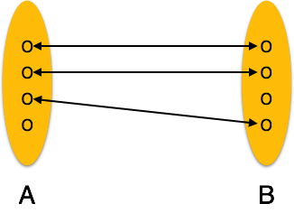

* **One-to-many** − One entity from entity set A can be associated with more than one entities of entity set B however an entity from entity set B, can be associated with at most one entity.

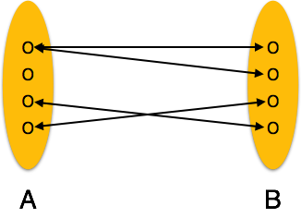

* **Many-to-one** − More than one entities from entity set A can be associated with at most one entity of entity set B, however an entity from entity set B can be associated with more than one entity from entity set A.

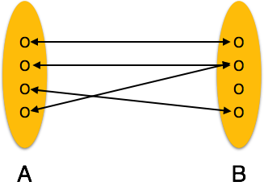

* **Many-to-many** − One entity from A can be associated with more than one entity from B and vice versa.

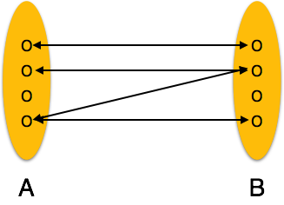

## ER Model:

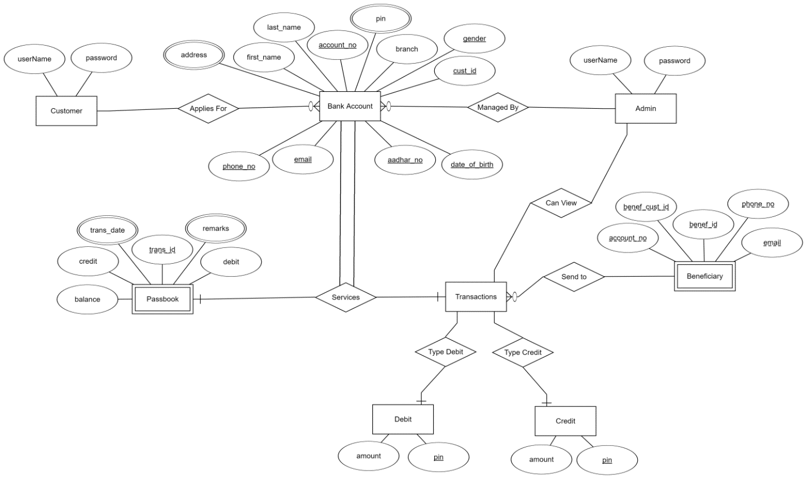

## 3.2 Relational Model

## Relational data model is the primary data model, which is used widely around the world for data storage and processing. This model is simple and it has all the properties and capabilities required to process data with storage efficiency.

Tables − In relational data model, relations are saved in the format of Tables. This format stores the relation among entities. A table has rows and columns, where rows represent records and columns represent the attributes.

Tuple − A single row of a table, which contains a single record for that relation is called a tuple.

Relation instance − A finite set of tuples in the relational database system represents relation instance. Relation instances do not have duplicate tuples.

Relation schema − A relation schema describes the relation name (table name), attributes, and their names.

Relation key − Each row has one or more attributes, known as relation key, which can identify the row in the relation (table) uniquely.

Attribute domain − Every attribute has some pre-defined value scope, known as attribute domain.

## Constraints

Every relation has some conditions that must hold for it to be a valid relation. These conditions are called Relational Integrity Constraints. There are three main integrity constraints −

* Key constraints
* Domain constraints
* Referential integrity constraints

### Key Constraints

There must be at least one minimal subset of attributes in the relation, which can identify a tuple uniquely. This minimal subset of attributes is called key for that relation. If there is more than one such minimal subset, these are called *candidate keys*.

Key constraints force that −

* In a relation with a key attribute, no two tuples can have identical values for key attributes.
* A key attribute cannot have NULL values.

Key constraints are also referred to as Entity Constraints.

### Domain Constraints

Attributes have specific values in real-world scenario. For example, age can only be a positive integer. The same constraints have been tried to employ on the attributes of a relation. Every attribute is bound to have a specific range of values. For example, age cannot be less than zero and telephone numbers cannot contain a digit outside 0-9.

### Referential integrity Constraints

Referential integrity constraints work on the concept of Foreign Keys. A foreign key is a key attribute of a relation that can be referred in other relation.

Referential integrity constraint states that if a relation refers to a key attribute of a different or same relation, then that key element must exist.

## 3.3 ER-Relational Mapping

ER Model, when conceptualized into diagrams, gives a good overview of entity-relationship, which is easier to understand. ER diagrams can be mapped to relational schema, that is, it is possible to create relational schema using ER diagram. We cannot import all the ER constraints into relational model, but an approximate schema can be generated.

There are several processes and algorithms available to convert ER Diagrams into Relational Schema. Some of them are automated and some of them are manual. We may focus here on the mapping diagram contents to relational basics.

ER diagrams mainly comprise of −

* Entity and its attributes
* Relationship, which is association among entities.

## Mapping Entity

An entity is a real-world object with some attributes.

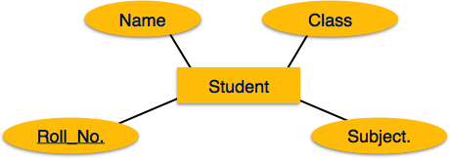

### Mapping Process (Algorithm)

* Create table for each entity.
* Entity's attributes should become fields of tables with their respective data types.
* Declare primary key.

## Mapping Relationship

A relationship is an association among entities.

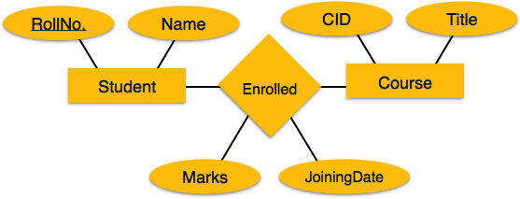

### Mapping Process

* Create table for a relationship.
* Add the primary keys of all participating Entities as fields of table with their respective data types.
* If relationship has any attribute, add each attribute as field of table.
* Declare a primary key composing all the primary keys of participating entities.
* Declare all foreign key constraints.

## Mapping Weak Entity Sets

A weak entity set is one which does not have any primary key associated with it.

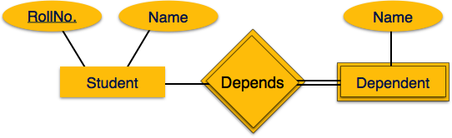

### Mapping Process

* Create table for weak entity set.
* Add all its attributes to table as field.
* Add the primary key of identifying entity set.
* Declare all foreign key constraints.

## Mapping Hierarchical Entities

ER specialization or generalization comes in the form of hierarchical entity sets.

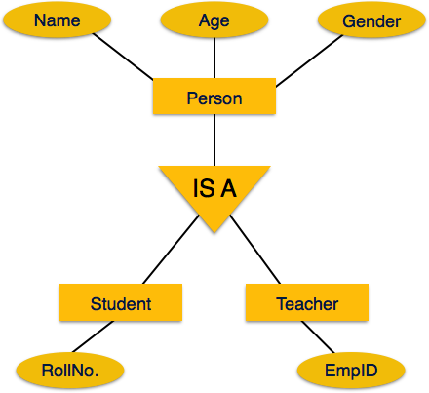

### Mapping Process

* Create tables for all higher-level entities.
* Create tables for lower-level entities.
* Add primary keys of higher-level entities in the table of lower-level entities.
* In lower-level tables, add all other attributes of lower-level entities.
* Declare primary key of higher-level table and the primary key for lower-level table.
* Declare foreign key constraints.

CUSTOMER

|  |  |
| --- | --- |
| Username | Password |

BANK ACCOUNT

|  |  |  |  |  |  |  |  |  |  |  |  |
| --- | --- | --- | --- | --- | --- | --- | --- | --- | --- | --- | --- |
| First_name | Last_name | Account_no | pin | branch | gender | Cust_id | Phone_no | email | Aadhar_no | Dob | address |

ADMIN

|  |  |
| --- | --- |
| username | password |

BENIFICIARY

|  |  |  |  |  |
| --- | --- | --- | --- | --- |
| Account_no | Benef_cust_id | Benef_id | Phone_no | email |

PASSBOOK

|  |  |  |  |  |  |
| --- | --- | --- | --- | --- | --- |
| Balance | credit | debit | Trans_id | remarks | Trans_date |

DEBIT

|  |  |
| --- | --- |
| amount | pin |

CREDIT

|  |  |
| --- | --- |
| amount | pin |

TRANSACTIONS

|  |  |
| --- | --- |
| Trans_id | pin |

Chapter IV

# Database Normalization

* Normalization is the process of organizing the data in the database.
* Normalization is used to minimize the redundancy from a relation or set of relations. It is also used to eliminate the undesirable characteristics like Insertion, Update and Deletion Anomalies.
* Normalization divides the larger table into the smaller table and links them using relationship.
* The normal form is used to reduce redundancy from the database table.

## Types of Normal Forms

There are the four types of normal forms:

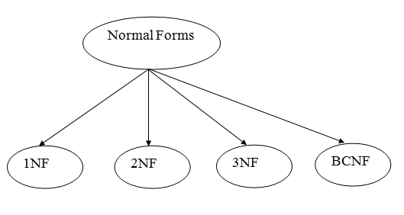

|  |  |
| --- | --- |
| **Normal Form** | **Description** |
| [1NF](https://www.javatpoint.com/dbms-first-normal-form) | A relation is in 1NF if it contains an atomic value. |
| [2NF](https://www.javatpoint.com/dbms-second-normal-form) | A relation will be in 2NF if it is in 1NF and all non-key attributes are fully functional dependent on the primary key. |
| [3NF](https://www.javatpoint.com/dbms-third-normal-form) | A relation will be in 3NF if it is in 2NF and no transition dependency exists. |
| [4NF](https://www.javatpoint.com/dbms-forth-normal-form) | A relation will be in 4NF if it is in Boyce Codd normal form and has no multi-valued dependency. |
| [5NF](https://www.javatpoint.com/dbms-fifth-normal-form) | A relation is in 5NF if it is in 4NF and not contains any join dependency and joining should be lossless. |

CUSTOMER

|  |  |
| --- | --- |
| Username | Password |

BANK ACCOUNT

|  |  |  |  |  |  |  |  |  |  |  |  |
| --- | --- | --- | --- | --- | --- | --- | --- | --- | --- | --- | --- |
| First_name | Last_name | Account_no | pin | branch | gender | Cust_id | Phone_no | email | Aadhar_no | Dob | address |

ADMIN

|  |  |
| --- | --- |
| username | password |

BENIFICIARY

|  |  |  |  |  |
| --- | --- | --- | --- | --- |
| Account_no | Benef_cust_id | Benef_id | Phone_no | email |

PASSBOOK

|  |  |  |  |  |  |
| --- | --- | --- | --- | --- | --- |
| Balance | credit | debit | Trans_id | remarks | Trans_date |

DEBIT

|  |  |
| --- | --- |
| amount | pin |

CREDIT

|  |  |
| --- | --- |
| amount | pin |

TRANSACTIONS

|  |  |
| --- | --- |
| Trans_id | pin |

Lab Project Report on

“Online Banking”

Carried out By

**Batch No:**

|  |  |
| --- | --- |
| Name of Students | USN |
| Rohan Kokatanur | 2GI18IS066 |
| Hemanth I T | 2GI18IS015 |
| Laxmi M N | 2GI18IS020 |
| Rachana Kampli | 2GI18IS032 |

Under the Guidance of

**Prof.Sudhindra B.Deshpande**

**KLS, GIT, Department of ISE, Belagavi**

**Course Name: Database Management System Lab**

**Semester: IV**

**Course Code: 18ISL48**

**DEPARTMENT of INFORMATION SCIENCE AND ENGINEERING**

**Academic Year 2019-20**

**Lab project report and ppt content**

1. Title

2. Problem statement for that the project

3. Need Analysis, Variables involved

4. Atleast two alternate solutions to solve the problem defined or meet the need analysis

5. Comparison between the solutions and reason for selecting the final solution

6. Working model of the final solution

**Marks allocation:**

|  |  |  |  |  |  |  |
| --- | --- | --- | --- | --- | --- | --- |
|  | Batch No. : | | | | | |
| 1. | Project Title: | Marks Range | USN | | | |
|  |  |  |  |
| 2. | Problem statement (PO2) | 0-1 |  |  |  |  |
| 3. | Need Analysis, Variables involved (PO1,PO2) | 0-2 |  |  |  |  |
| 4. | Alternate solutions to solve the problem(PO3) | 0-3 |  |  |  |  |
| 5. | Comparison between the solutions and reason for selecting the final solution(PO1,PO3,PO4) | 0-4 |  |  |  |  |
| 6. | Working model of the final solution (PO3,PO12) | 0-5 |  |  |  |  |
| 7. | Report and Oral presentation skill (PO9,PO10) | 0-5 |  |  |  |  |
|  | Total | 20 |  |  |  |  |

**\* 20 marks is converted to 10 marks for CGPA calculation**

**1.Engineering Knowledge:** Apply the knowledge of mathematics, science, engineering fundamentals and an engineering specialization to the solution of complex engineering problems.

**2.Problem Analysis:** Identify, formulate, review research literature, and analyze complex engineering problems reaching substantiated conclusions using first principles of mathematics, natural sciences and Engineering sciences.

**3.Design/Development of solutions:**Design solutions for complex engineering problems and design system components or processes that meet the specified needs with appropriate consideration for the public health and safety, and the cultural, societal, and environmental considerations.

**4.Conduct investigations of complex problems:** Use research-based knowledge and research methods including design of experiments, analysis and interpretation of data, and synthesis of the information to provide valid conclusions.

**5.Modern tool usage:**Create, select, and apply appropriate techniques, resources, and modern engineering and IT tools including prediction and modeling to complex engineering activities with an understanding of the limitations.

**6.The engineer and society:**Apply reasoning informed by the contextual knowledge to assess societal, health, safety, legal and cultural issues and the consequent responsibilities relevant to the professional engineering practice.

**7.Environment and sustainability:** Understand the impact of the professional engineering solutions in societal and environmental contexts, and demonstrate the knowledge of, and need

for sustainable development.

**8.Ethics:** Apply ethical principles and commit to professional ethics and responsibilities and norms of the engineering practice.

**9.Individual and team work:** Function effectively as an individual and as a member or leader in diverse teams, and in multidisciplinary settings.

**10.Communication:** Communicate effectively on complex engineering activities with the engineering community and with society at large, such as, being able to comprehend and write effective reports and design documentation, make effective presentations, and give and receive clear instructions.

**11. Project management and finance:** Demonstrate knowledge and understanding of the engineering management principles and apply these to one's own work, as a member and leader in a team, to manage projects and in multidisciplinary environments.

**12. Life-long learning:** Recognize the need for and have the preparation and ability to engage in independent and lifelong learning in the broadest context of technological change.

Chapter V

# Table creations

CREATE table statements with all the constraints…

* 1. CREATE TABLE `admin` ( `id` int(11) NOT NULL AUTO_INCREMENT,`uname` char(25) DEFAULT NULL,`pwd` char(25) DEFAULT NULL, PRIMARY KEY (`id`)) ENGINE=InnoDB AUTO_INCREMENT=2 DEFAULT CHARSET=latin1;
  2. CREATE TABLE `beneficiary1` (`benef_id` int(11) NOT NULL AUTO_INCREMENT,`benef_cust_id` int(11) DEFAULT NULL,`email` varchar(30) DEFAULT NULL,`phone_no` varchar(20) DEFAULT NULL,`account_no` int(11) DEFAULT NULL,PRIMARY KEY (`benef_id`),UNIQUE KEY `benef_cust_id` (`benef_cust_id`),UNIQUE KEY `email` (`email`),UNIQUE KEY `phone_no` (`phone_no`),UNIQUE KEY `account_no` (`account_no`)) ENGINE=InnoDB AUTO_INCREMENT=2 DEFAULT CHARSET=latin1;
  3. CREATE TABLE `beneficiary2` (`benef_id` int(11) NOT NULL AUTO_INCREMENT,`benef_cust_id` int(11) DEFAULT NULL,`email` varchar(30) DEFAULT NULL,`phone_no` varchar(20) DEFAULT NULL,`account_no` int(11) DEFAULT NULL, PRIMARY KEY (`benef_id`),UNIQUE KEY `benef_cust_id` (`benef_cust_id`),UNIQUE KEY `email` (`email`),UNIQUE KEY `phone_no` (`phone_no`),UNIQUE KEY ‘account_no` (`account_no`)) ENGINE=InnoDB AUTO_INCREMENT=2 DEFAULT CHARSET=latin1;
  4. CREATE TABLE `beneficiary3` (`benef_id` int(11) NOT NULL AUTO_INCREMENT,`benef_cust_id` int(11) DEFAULT NULL,`email` varchar(30) DEFAULT NULL,`phone_no` varchar(20) DEFAULT NULL,`account_no` int(11) DEFAULT NULL,PRIMARY KEY (`benef_id`),UNIQUE KEY `benef_cust_id` (`benef_cust_id`),UNIQUE KEY `email` (`email`),UNIQUE KEY `phone_no` (`phone_no`),UNIQUE KEY `account_no` (`account_no`)) ENGINE=InnoDB DEFAULT CHARSET=latin1;
  5. CREATE TABLE `beneficiary4` (`benef_id` int(11) NOT NULL AUTO_INCREMENT,`benef_cust_id` int(11) DEFAULT NULL,`email` varchar(30) DEFAULT NULL,`phone_no` varchar(20) DEFAULT NULL,`account_no` int(11) DEFAULT NULL,PRIMARY KEY (`benef_id`),UNIQUE KEY `benef_cust_id` (`benef_cust_id`),UNIQUE KEY `email` (`email`),UNIQUE KEY `phone_no` (`phone_no`),UNIQUE KEY `account_no` (`account_no`)) ENGINE=InnoDB DEFAULT CHARSET=latin1;
  6. CREATE TABLE `customer` (`cust_id` int(11) NOT NULL AUTO_INCREMENT,`first_name` varchar(30) DEFAULT NULL,`last_name` varchar(30) DEFAULT NULL,`gender` varchar(10) DEFAULT NULL,`dob` date DEFAULT NULL,`aadhar_no` int(11) DEFAULT NULL,`email` varchar(30) DEFAULT NULL,`phone_no` varchar(20) DEFAULT NULL,`address` varchar(255) DEFAULT NULL,`branch` varchar(30) DEFAULT NULL,`account_no` int(11) DEFAULT NULL,`pin` int(4) DEFAULT NULL,`uname` varchar(30) DEFAULT NULL,`pwd` varchar(30) DEFAULT NULL,PRIMARY KEY (`cust_id`),UNIQUE KEY `aadhar_no` (`aadhar_no`),UNIQUE KEY `email` (`email`),UNIQUE KEY `phone_no` (`phone_no`),UNIQUE KEY `account_no` (`account_no`),UNIQUE KEY `uname` (`uname`)) ENGINE=InnoDB AUTO_INCREMENT=5 DEFAULT CHARSET=latin1;
  7. CREATE TABLE `news` (`id` int(10) unsigned NOT NULL AUTO_INCREMENT,`title` varchar(40) DEFAULT NULL,`created` datetime DEFAULT NULL,PRIMARY KEY (`id`)) ENGINE=InnoDB AUTO_INCREMENT=5 DEFAULT CHARSET=latin1;
  8. CREATE TABLE `news_body` (`id` int(10) unsigned NOT NULL AUTO_INCREMENT,`body` text,PRIMARY KEY (`id`)) ENGINE=InnoDB AUTO_INCREMENT=5 DEFAULT CHARSET=latin1;
  9. CREATE TABLE `passbook1` (`trans_id` int(11) NOT NULL AUTO_INCREMENT,`trans_date` datetime DEFAULT NULL,`remarks` varchar(255) DEFAULT NULL,`debit` int(11) DEFAULT NULL,`credit` int(11) DEFAULT NULL,`balance` int(11) DEFAULT NULL,PRIMARY KEY (`trans_id`)) ENGINE=InnoDB AUTO_INCREMENT=10 DEFAULT CHARSET=latin1;
  10. CREATE TABLE `passbook2` (`trans_id` int(11) NOT NULL AUTO_INCREMENT,`trans_date` datetime DEFAULT NULL,`remarks` varchar(255) DEFAULT NULL,`debit` int(11) DEFAULT NULL,`credit` int(11) DEFAULT NULL,`balance` int(11) DEFAULT NULL,PRIMARY KEY (`trans_id`)) ENGINE=InnoDB AUTO_INCREMENT=16 DEFAULT CHARSET=latin1;
  11. CREATE TABLE `passbook3` (`trans_id` int(11) NOT NULL AUTO_INCREMENT,`trans_date` datetime DEFAULT NULL,`remarks` varchar(255) DEFAULT NULL,`debit` int(11) DEFAULT NULL,`credit` int(11) DEFAULT NULL,`balance` int(11) DEFAULT NULL,PRIMARY KEY (`trans_id`)) ENGINE=InnoDB AUTO_INCREMENT=10 DEFAULT CHARSET=latin1;
  12. CREATE TABLE `passbook4` (`trans_id` int(11) NOT NULL AUTO_INCREMENT,`trans_date` datetime DEFAULT NULL,`remarks` varchar(255) DEFAULT NULL,`debit` int(11) DEFAULT NULL,`credit` int(11) DEFAULT NULL,`balance` int(11) DEFAULT NULL,PRIMARY KEY (`trans_id`)) ENGINE=InnoDB AUTO_INCREMENT=10 DEFAULT CHARSET=latin1;

Chapter VI

# 6.Populating Tables

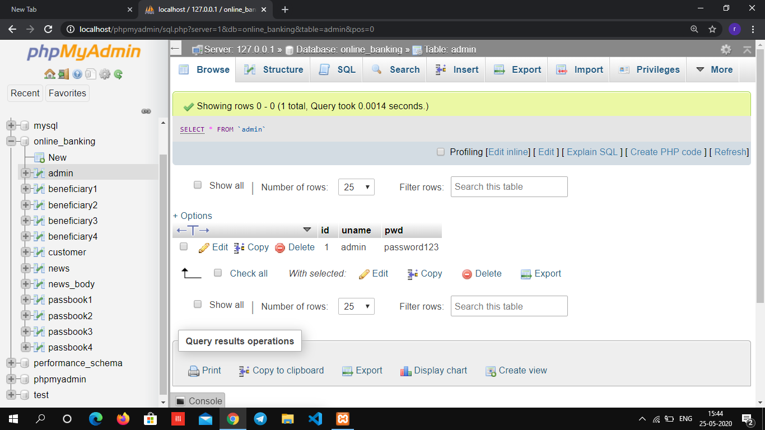

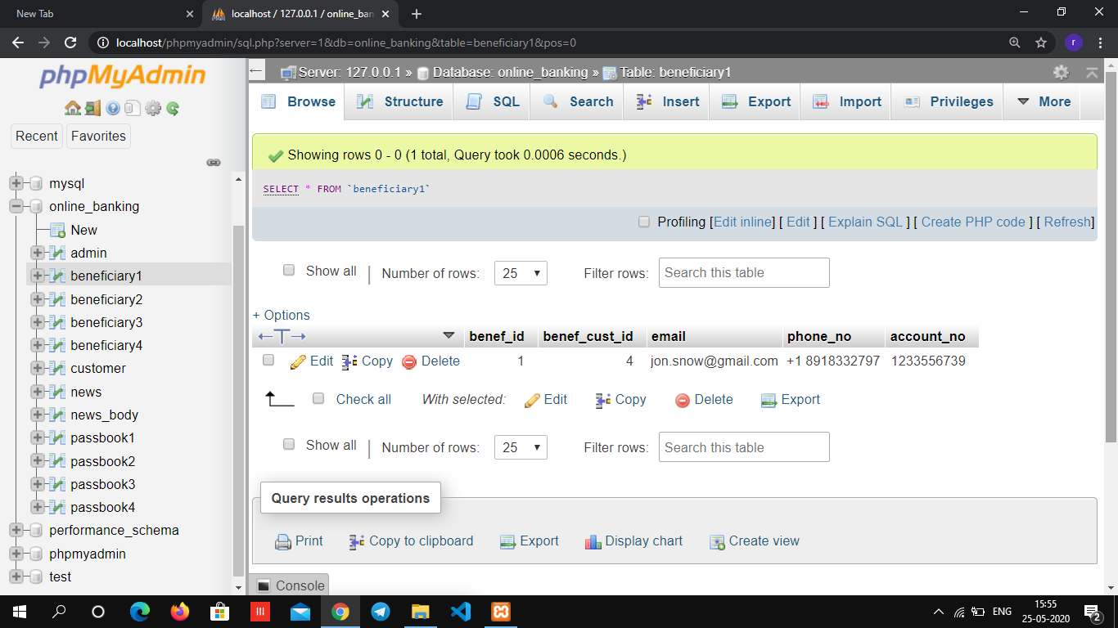

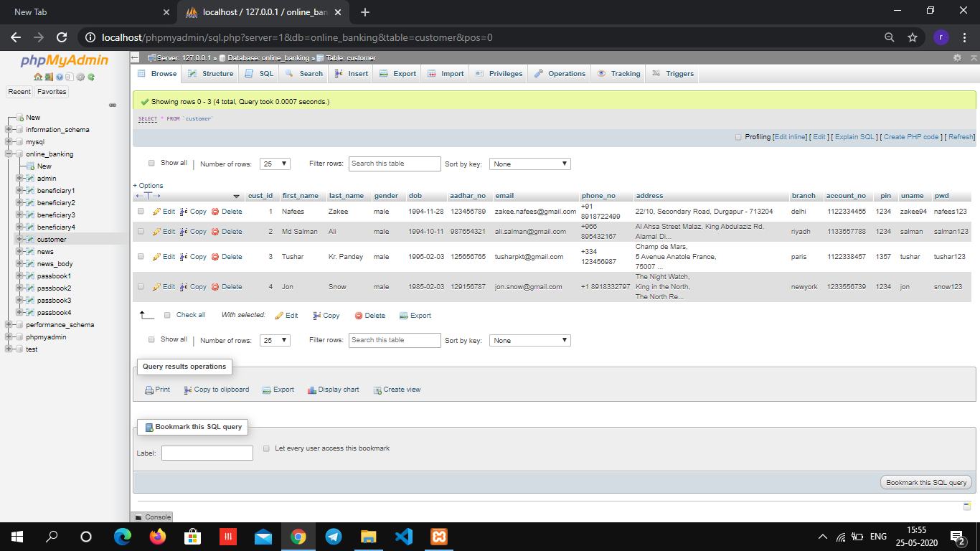

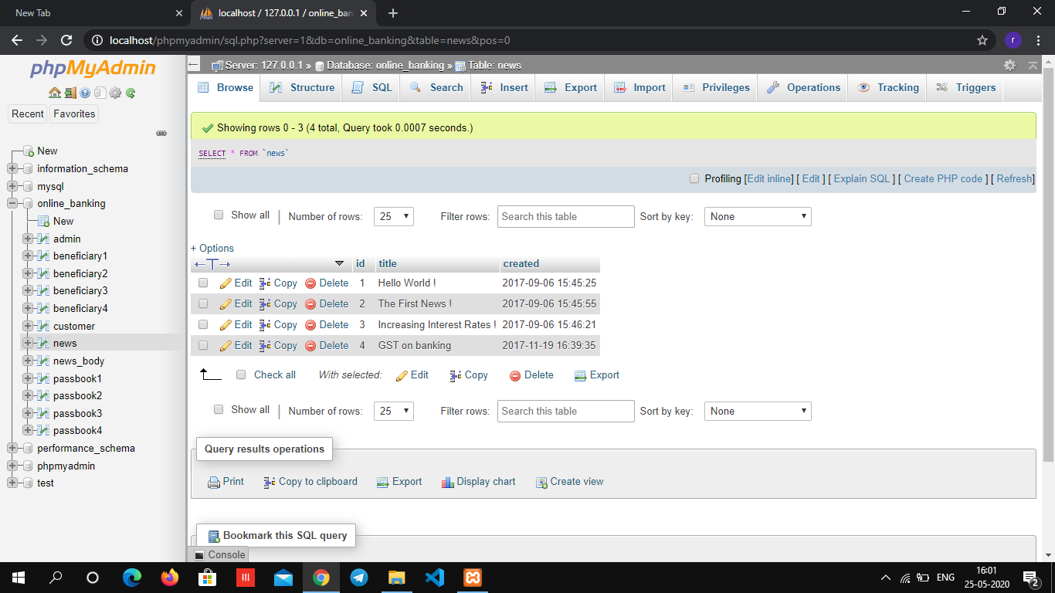

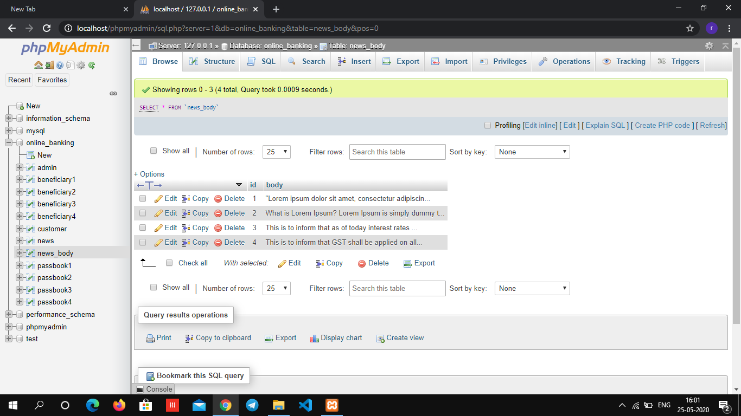

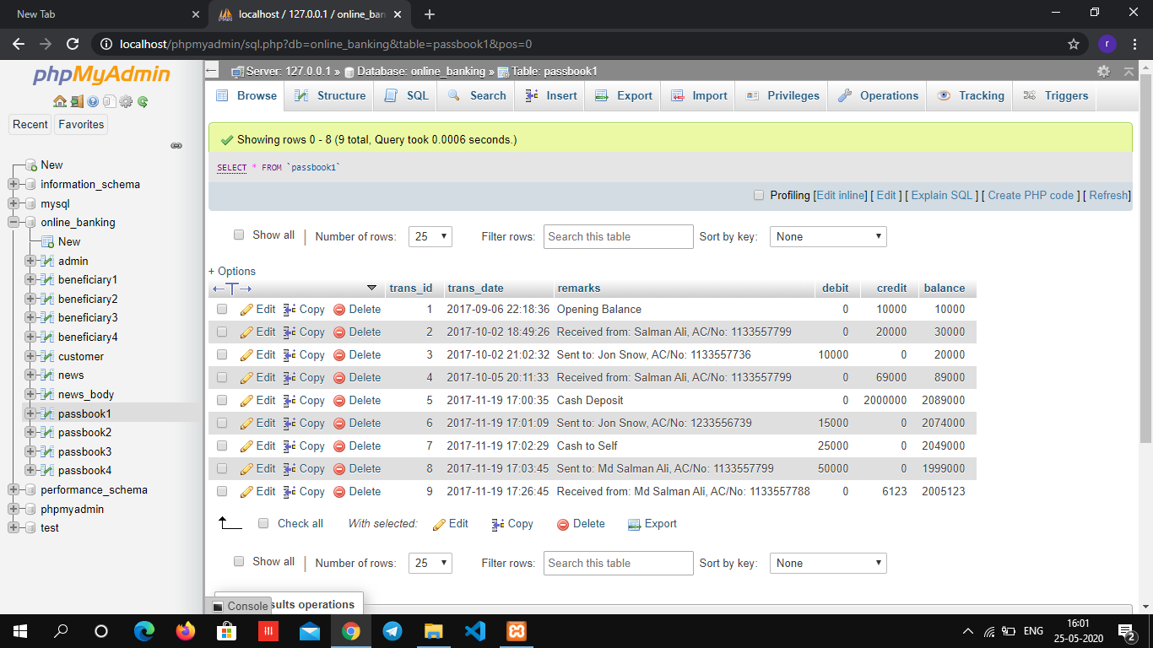

Chapter VII

# User Interface Designs

//create one or two PHP or JAVA interfaces to access any of SQL tables created above

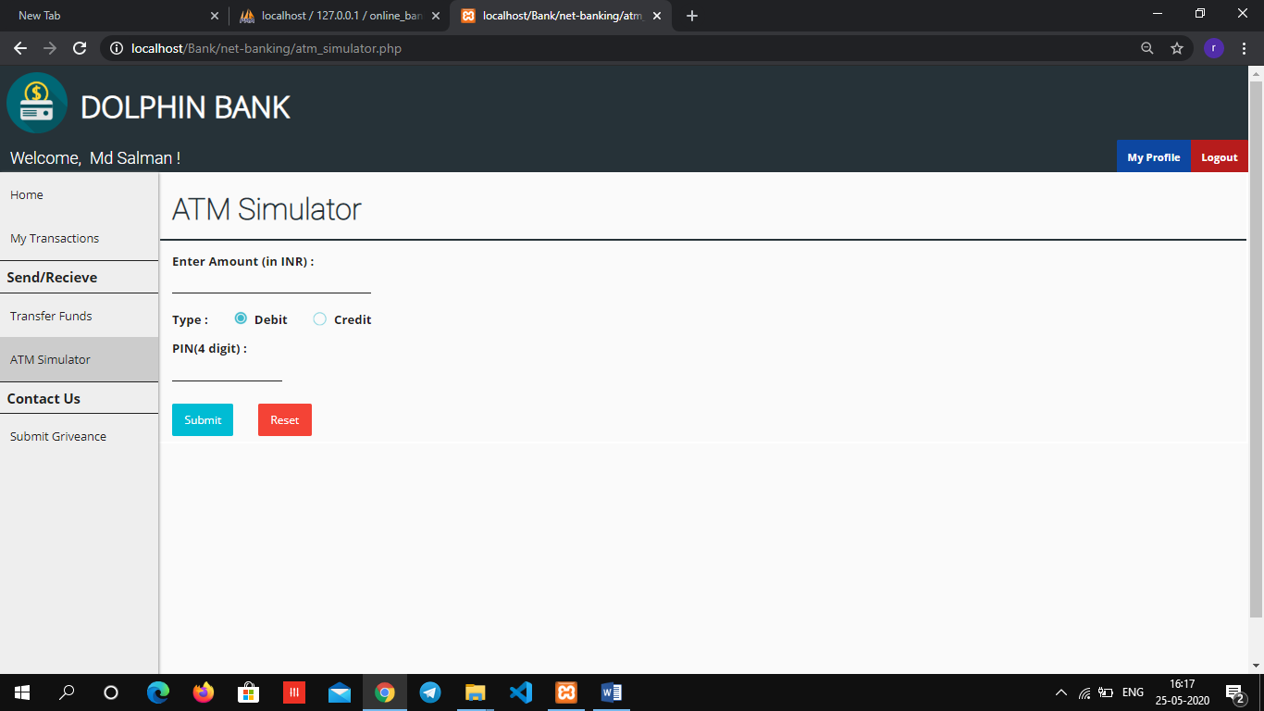

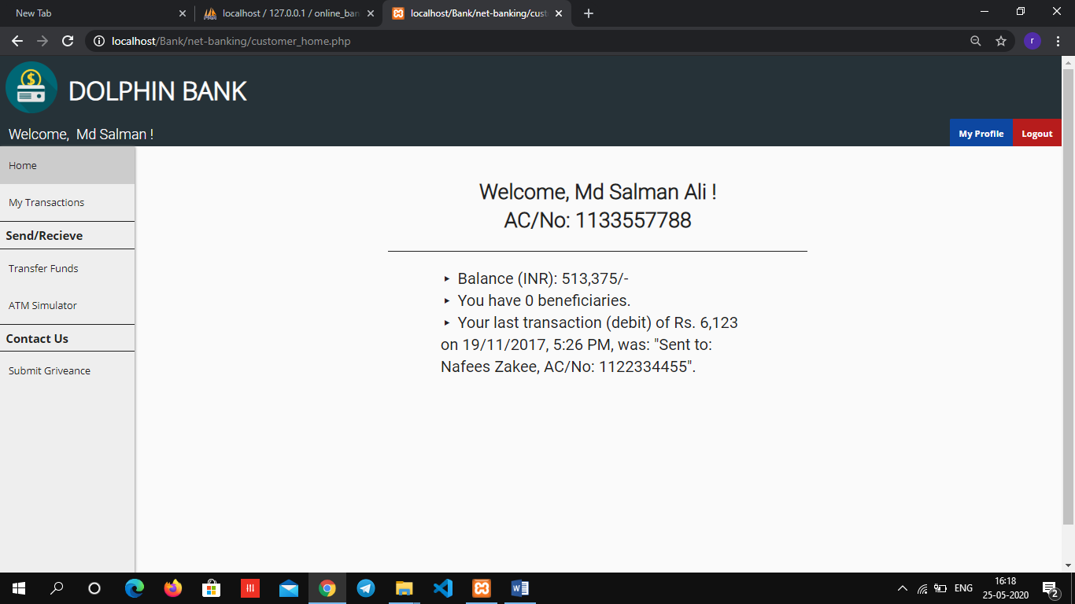

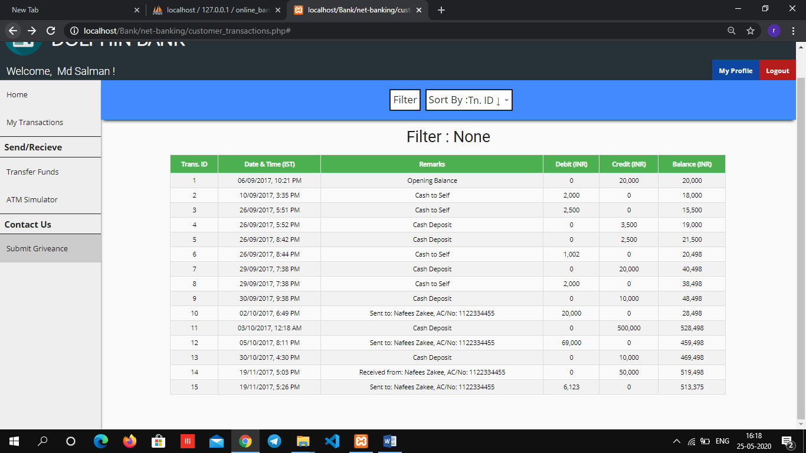

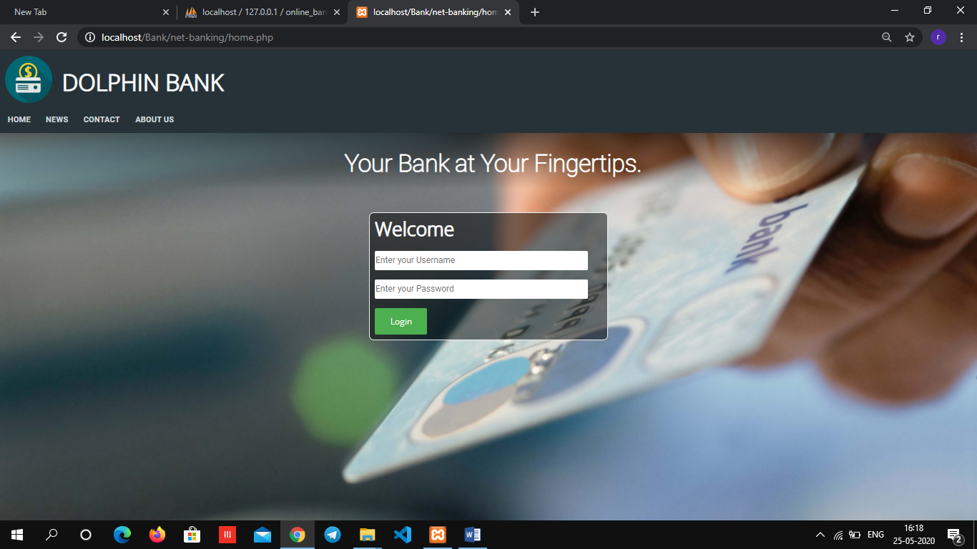

Chapter VIII

# SQL Queries

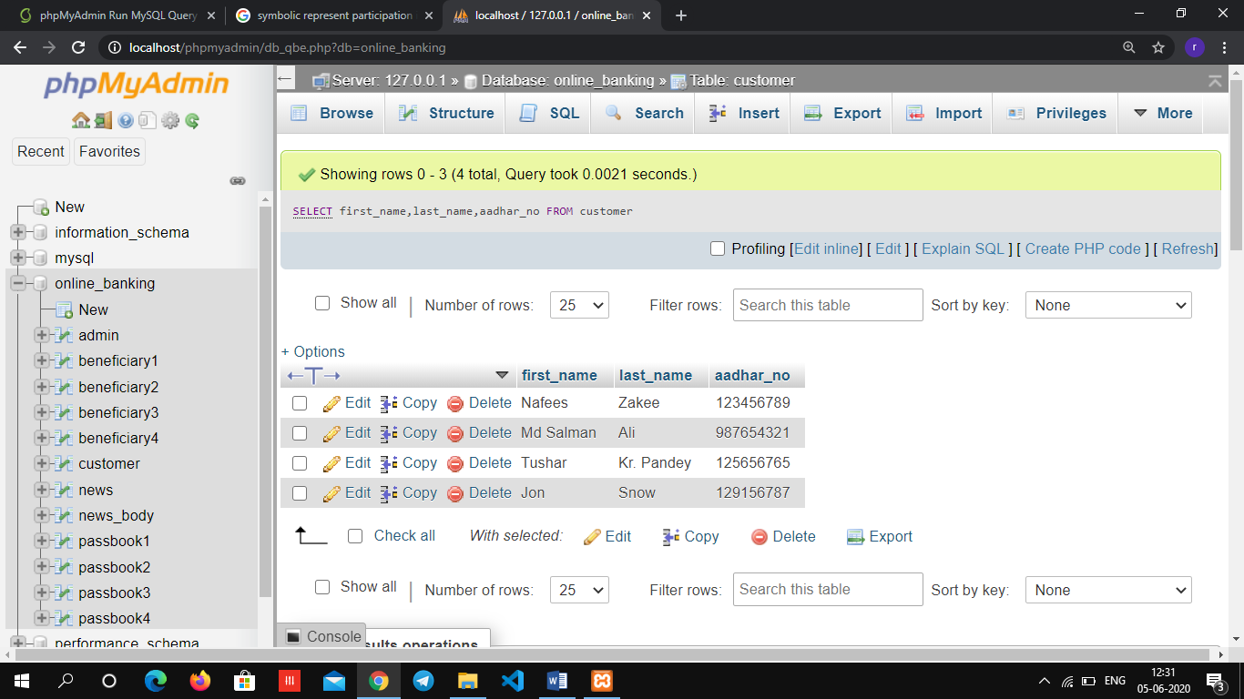

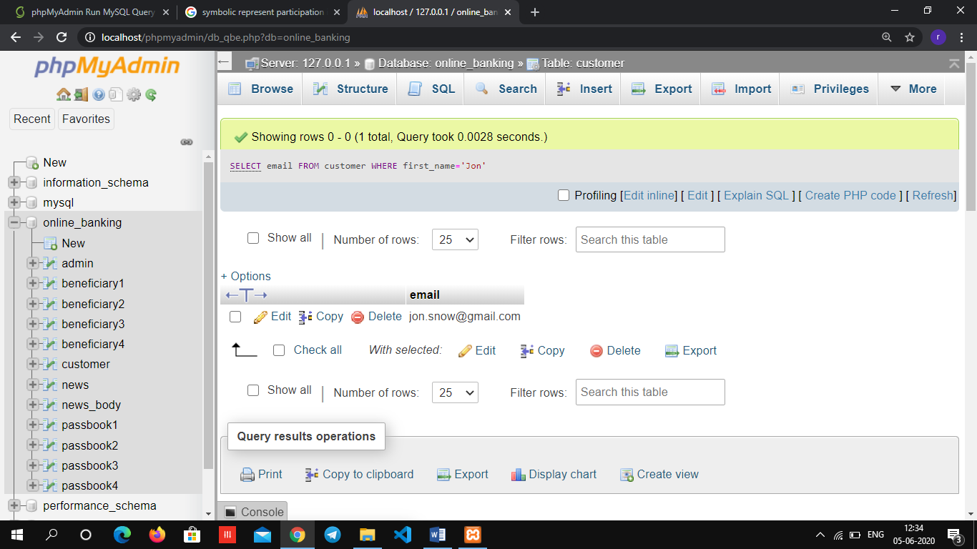

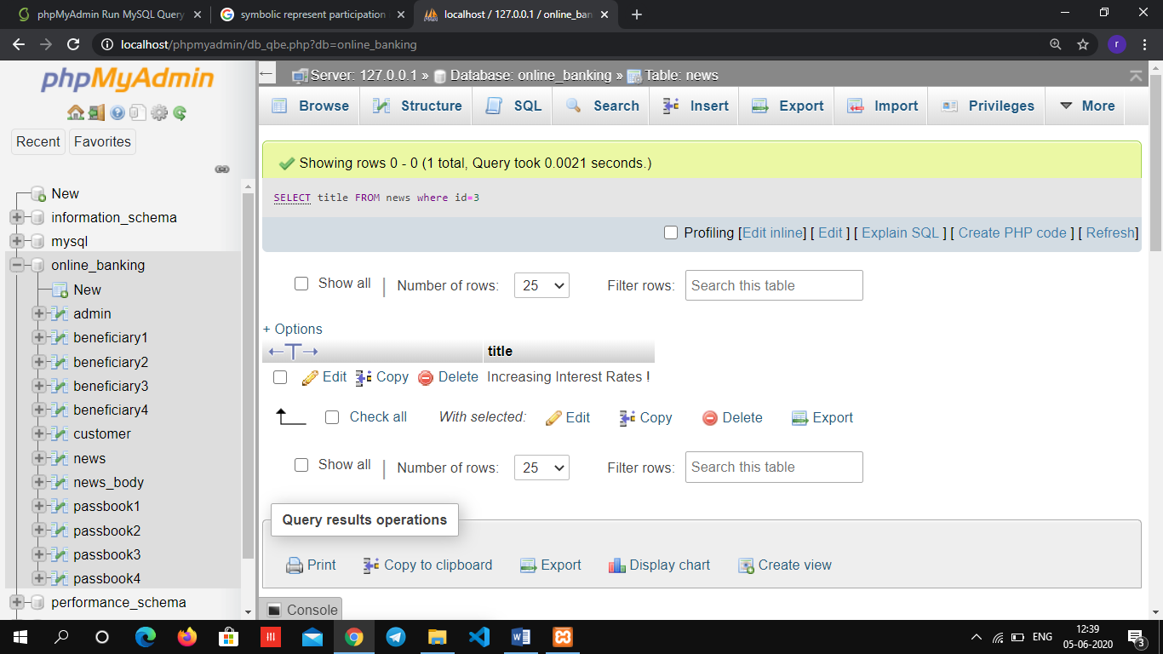

# 9.Conclusions

A database management system is important because it manages data efficiently and allows users to perform multiple tasks with ease. A database management system stores, organizes and manages a large amount of information within a single software application. Use of this system increases efficiency of business operations and reduces overall costs.

Database management systems are important to businesses and organizations because they provide a highly efficient method for handling multiple types of data. Some of the data that are easily managed with this type of system include: employee records, student information, payroll, accounting, project management, inventory and library books. These systems are built to be extremely versatile.

Without database management, tasks have to be done manually and take more time. Data can be categorized and structured to suit the needs of the company or organization. Data is entered into the system and accessed on a routine basis by assigned users. Each user may have an assigned password to gain access to their part of the system. Multiple users can use the system at the same time in different ways.

Third normal form (3NF) is a database schema design approach for relational databases which uses normalizing principles to reduce the duplication of data, avoid data anomalies, ensure referential integrity, and simplify data management.

During our database management course we have learned about the basics of database design. This project gave us the opportunity to try our new skills in practice. While doing this project we also gained deeper understanding on database design and how it can be implemented in real life situations. We believe we can use our database designing skills also in other school projects.

# 10.References

1. <https://www.tutorialspoint.com/dbms>
2. <https://www.ntu.edu.sg/home/ehchua/programming/sql>
3. <https://en.wikipedia.org/wiki/Database>
4. [Fourth Semester Xerox Notes](https://github.com/CrazyKeedas-GIT-Nerds)

# References

//Add books and internet material that you have referred